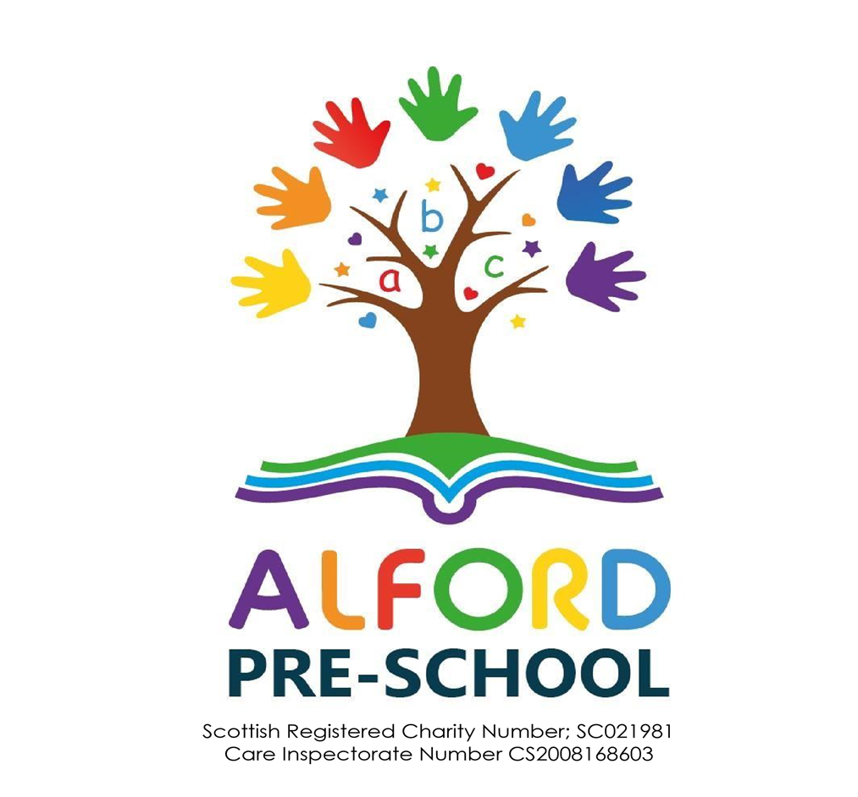

2024-25
Information Booklet
Last updated 23.02.25

West Gordon Parish Church Hall, 110 Main Street, Alford, AB33 8AD
Email; alfordpreschool@outlook.com Website; alfordpreschool.co.uk
Tel No; (019755) 63505 Mobile No; 07598 330206

Contents

Page 3 Welcome and a little about us!

Page 4 & 5 Learning Provision, Frameworks and Guidelines

Page 6 Child Protection Guidance and Approach

Page 7 Unfunded, Funded & Self-Funded Places & fees

Page 8 | Staff
Page 9 | Settling in Policy and Drop Off Guidance
Page 10 | Clothing and what you need to know
Page 11 | What happens during a session?
Page 12 | Communication, Absences & Medication

Page 13 Closures

Page 14 Parent Carer sessions

Page 15 & 16 Committee, Roles, Fundraising and Procedures

Welcome to Alford Pre-School!

On behalf of the Staff and Committee welcome to Alford Pre-School.
This booklet provides information for parents and carers and should answer any questions that you may have, however should you have any queries please either speak to a member of staff or email us at alfordpreschool@outlook.com

A little about us….

Established for almost 60 years we continue to place the principles of fun, friendship and learning in a safe and stimulating environment at the heart of our ethos. As a Registered Scottish Charity, we are run by a Voluntary Committee comprising of parents/carers of children attending setting together with interested parties.


We are a Partner Provider for Aberdeenshire Council providing provision for funded places for early learning. We work together with Aberdeenshire Council Development workers and Early Years Principal Teachers who regularly attend sessions to support and enhance children’s learning.


We are registered with the Care Inspectorate who carry out inspections and grade the quality of our setting. Our most recent inspection, March 2024, grades are as detailed below, and you can view our full inspection report by clicking on the following link;
file:///C:/Users/alfor/Downloads/InspectionReport-319032%20(3).pdf

How good is our care, play and learning? 4 – Good
How good is our setting? 4 - Good
How good is our leadership? 4 - Good
How good is our staff team? 4 – Good


HMI Education Scotland is a Scottish Government executive agency responsible for supporting quality and improvement in Scottish Education. Carrying out inspections in early learning and childcare, HMI Education Scotland aims to promote improvement in early learning and childcare settings and successful innovation that enhances children’s learning and development.
Our most recent summary inspection findings (SIF), August 2017, can be viewed by in the entrance vestibule and our Policy, Procedures and Guidelines book.

Learning Provision, Frameworks and Guidelines

Our setting applies the following frameworks, guidelines, and policies to support and enhance children’s learning and development.

Curriculum for Excellence is the framework for 3yrs to 18yr olds which places learners at the heart of education. At its centre are four fundamental capacities. These capacities reflect and recognise the lifelong nature of education and learning.

The four capacities are aimed at helping children and young people to become:
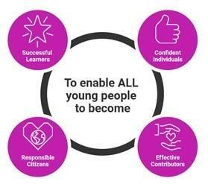
- Successful Learners
- Confident Individuals
- Responsible Citizens
- Effective Contributors

Curriculum for Excellence provides a broad general education for all which includes well planned experiences and outcomes across the curriculum. The broad general education has five levels (early, first, second, third and fourth) applying the following curriculum areas:

- Health and wellbeing
- English and Literacy
- Numeracy and Mathematics
- Sciences
- Social studies
- Technologies
- Expressive arts
- Religious and moral education
Curriculum for Excellence Benchmarks set out clear statements about what learners need to know and be able to do to achieve a level across all curriculum areas. Experiences and outcomes (often called Es+Os) are a set of clear and concise statements about children's learning and progression in each curriculum area. They are used to help plan learning and to assess progress.
You can find more information on Curriculum for Excellence by clicking on this link; https://education.gov.scot/media/dedaepof/earlylevelbenchmarksallareaspdf.pdf
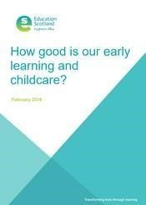
HMI Education Scotland How good is our early learning and childcare? (2016) (HGIOELC) This framework provides a self-improvement tool using challenge questions based on the 15 quality indicators (QIs), which are organised into three key areas: Leadership and Management, Learning Provision and Successes & Achievements. This tool is used to ensure quality of provision and identify where improvements are needed to be made. Click on the following link for more information.
https://education.gov.scot/inspection-and-review/inspection-frameworks/how-good-is-our-early-learning-and-childcare/

Care Inspectorate Quality Framework (2022). This framework is a tool for self-evaluation of performance in delivering quality care and learning for children. The framework supports settings to identify strengths and areas for improvement applying self-evaluation based on 5 Key Questions;

1. How good is our care, play and learning? 2. How good is our setting?
3. How good is our leadership? 4. How good is our staff team?
5. What is our overall capacity for improvement?
This quality framework focuses on children’s well-being and sets out the elements that help us answer key questions about the impact that care and learning is having on outcomes for children. Click on the following link for more information.
https://hub.careinspectorate.com/resources/quality-frameworks-and-kq7s/

Education Scotland Realising the Ambition “Being Me” (2020) early years national practice guidance. This guidance explores the range of interactions, experiences, and spaces we need to provide to support children to help them learn and grow best from their earliest days through to being a young child in early primary school. This increases expectations of high-quality provision within the early years sector and beyond. Click on the following link for more information.
https://education.gov.scot/improvement/learning-resources/realising-the-ambition/

Scottish Government National Care Standards (2017) Sets out standards that you can expect when using health and social services in Scotland. These standards are applied by the Care Inspectorate for assessment during inspections of quality, safety, and effectiveness of care.
Click on the following link for more information.
https://hub.careinspectorate.com/national-policy-andlegislation/health-and-social-carehttps://hub.careinspectorate.com/national-policy-and-legislation/health-and-social-care-standards/standards/


National Guidance for Child Protection in Scotland (2021). This guidance describes the responsibilities and expectations for all involved in protecting children and will support the care and protection of children. This guidance reflects the greater integration of child protection within the Getting it right for every child (GIRFEC) continuum and use GIRFEC language and core components to frame identification and proportionate responses to child protection concerns within the National Practice Model.
Click on the following link for more information.
https://www.gov.scot/publications/national-guidance-child-protection-scotland-2021-updated-2023/documents/


Getting It Right for Every Child Aberdeenshire (2021) (GIRFEC) is the national approach aiming to safeguard, support and promote children and young people’s wellbeing. This approach is embedded across by Scotland by the Scottish Government, Public Agencies, Third Sector Organisations, and Partner Providers. It ensures that families are supported by making sure children and young people can receive the right help, at the right time, from the right people. Click on the following link for more information. https://www.girfec-aberdeenshire.org/

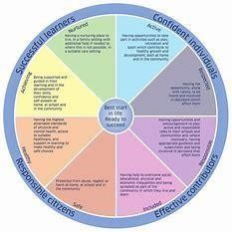
Wellbeing (SHANARRI). The Getting it right for every child (GIRFEC) approach supports children and young people so that they can grow up feeling loved, safe, and respected and can realise their full potential. At home, in school or the wider community, every child and young person should be:

Safe Healthy Achieving Nurtured Active Respected Responsible Included

The eight indicators (SHANARRI) help make it easier for children and families and the people working with them to discuss how a child or young person is doing at a point in time and if there is a need for support. Click on the following links for more information.

https://www.gov.scot/policies/girfec/wellbeing-indicators-
shanarri/#:~:text=These%20eight%20factors%20are%20often%20referred%20to%20by,and%20i
f%20there%20is%20a%20need%20for%20support.

Unfunded, Funded and Self-Funded Places

We operate a waiting list for children based on the date of enquiry and child’s date of birth.

Unfunded Places
When is my child entitled to an unfunded place?
Unfunded places are offered the term prior to your child’s funded place commencing and are dependent upon availability.

Unfunded Fees

Unfunded fees are currently £24.00 per session* inclusive of snack for a session time from 9am to 12.30pm. Unfunded fees may be payable weekly, monthly, or termly (please indicate your choice when returning your unfunded Acceptance Letter).

Please note that fees are required to be paid if your child is absent.

2 Nurture Place This is provided in conjunction with Aberdeenshire Council.

Funded Places
We provide funded places in conjunction with Aberdeenshire Council, as a Partner Provider, for early learning provision for eligible funded children from aged 2* to 5 years. Your child is entitled to 1140 hours of childcare per year, commencing on the first day of term each year. Alford Pre-School provide daily sessions during term time only from 8.30am to 12.30pm.

Self-funded places are subject to availability and are authorised by the committee.

Admissions 2024-25; When is my child entitled to a 3–5-year-old child eligible funded place? Your child must have had their 3rd birthday the day before the new term starts. Please note the start of term dates change each year.

If your child turns 3 by | Eligible for funding from
31.08.24 | August 2024
Before start of October term | 28.10.24
Before start of January term | 06.01.25
Before start of April term | 14.04.25

You must apply online to Aberdeenshire Council for funding. The funding process opens each year in January. Please click on the following link for further information.
https://www.aberdeenshire.gov.uk/social-care-and-health/childcare-and-early-
learning/find-nurseries/


Staff As a requirement of employment all staff are registered with SSSC (Scottish Social Services Council). This ensures that all staff work to Codes of Practice. For workers and employers,’ the Codes sets out the behaviours and values expected of social service workers and their employers and stipulate qualifications required to carry out their role.
Click on the following link for more information; https://www.sssc.uk.com/

Role | Name | Commenced  Employment | First  Aid Qual | Food  Hygiene Cert |  | Infection  Control  Certified | Qualifications
Manager | Jackie Rae | Aug 2012 | Yes | Yes | Yes |  | - Bachelor of Arts Degree  Childhood Practice  - SVQF Level 9  Social Services (Children & young People)  - SVQ3/SCQF Level 7  Children’s Care Learning & Development  - SVQF Level 6 PDA  Educational Support Ast
Childcare  Practitioner | Angie Minto | Mar 2015 | Yes | Yes | Yes |  | • HNC Child Care &  SVQ 3 Child Care and  Education
Support  Assistant | Sheena Cobban | Aug 2012 | Yes | Yes | Yes |  | - SVQF Level 6  Educational Support Ast
Support  Assistant | Terri Farr | Sept 2024 | Yes | Yes | Yes

Staff are required to undertake mandatory training in First Aid, Food Hygiene and Infection Control every three years in addition to further training to enhance their practice.

Staffing Ratio In accordance with Care Inspectorate guidance staffing ratios are as follows;

- to under 3 years 1 adult to 5 children 3 to under 8 years 1 adult to 8 children *

*Where children aged three and over attend settings for fewer than four hours in any one day the adult to child ratio can be one adult to 10 children
Click on the following for further information;
https://www.careinspectorate.com/images/documents/4334/Guidance%20on%20a dult%20to%20child%20ratios%20in%20early%20learning%20and%20childcare%20settin gs.pdf

Settling in Policy

We recognise that the transition between home is an important change for both children and Parent’s/Carer’s. All children are different, and some take longer than others to settle. We encourage you to stay for as many sessions as it takes for your child to settle. When it is time for you to leave your child, please make sure that you always say ‘Good-bye’ and that you return on time. If you have any doubts about when your child is ready to be left at the group, please discuss them with a member of staff. We are committed to working together with Parent’s/Carer’s to support settling in and will always put the best interests of the child at the centre of any decisions.

Settling in guidance
When joining us for settling in with your child we ask that you

- enter the vestibule with your child and assist them to change from their outdoor jacket and shoes before changing into their indoor shoes

- as you enter the hall please make your way to the sink at the side of the hallway and wash you and your child’s hands before beginning to play

Once your child has completed their settling in period and will be attending session on their own we ask that you

Drop Off Guidance
At drop off enter the vestibule to change your child from their outdoor clothing to indoor clothing (if play is inside). Please peg your child’s shoes together (with their named peg) and place under the bench where their name peg is. On entering the hall please advise duty practitioner at the desk of any relevant information, if child is unsettled/not been feeling well or any other issues that may impact them during their time with us during session.
Please ensure you advise the Duty Practitioner at the desk who shall be collecting your child at the end of session (this should be a contact stated on your forms).
Pick Up; If children are inside the hall at pick up time parents shall be required to change their child from their indoor to outdoor clothing.

Times;
Drop Off 8.30am to 9am
(please note the door shall be locked at 9.05am for security purposes, you will need to call us to gain entry after this time)
Core Learning Hours 9am to 12pm
Pick Up Time 12pm to 12.30pm

you may collect your child between these times but must be clear of Pre-School by 12.30pm

* Unfunded sessions
drop off 9am pick up 12.30pm

What you will need…
- a bag with your child’s name on it containing*
- indoor soft shoes (plimsoles, slippers or trainers – something with grip as we run around!)
- wellies/waterproof shoes for outdoor play
- puddle suit (all in one) or waterproofs
- a water bottle filled with water only
PLEASE ENSURE YOUR CHILD’S NAME IS ON EVERYTHING!
*Please bring in your child’s bag…
- Change of pants, socks, tops, bottoms
- Nappies, wipes, nappy bag and bag for soiled clothing to be returned home

***The bag should be taken each day and shall be returned home each day**
Your child shall have a name labelled coat hook and wooden peg in the entrance vestibule with your child’s name on it for your child to pop their bag and jacket on and peg their shoes together.

Clothing
Please ensure your child is dressed appropriately for the weather as we like to be outside as much as possible (waterproof jacket, suitable footwear, suncream - which should be applied before arriving at setting). As we regularly paint and get messy we would recommend that your child does not wear their best clothes to setting with loose fitting clothing being advisable.
As we work to develop your child’s confidence and independence we would encourage you to ensure your child’s clothing and footwear can support and develop independence (strappy shoes or wellies, no tightfitting clothing).
Pre-School clothing
Alford Pre-School polo shirts, t-shirts, hoodies, and fleece jackets are available to purchase. Please ask a member of staff for an order form. We have a limited number of pre-loved tops available – please enquire with staff regarding this.

Car parking
You will find designated parking located (signposted) off Correen Road, Alford AB33 8FP.
When parking please
- be aware of children exiting from other cars/vehicles and children who may be playing in the car park area
- supervise your own children
- park in parking bays
- if it is safe to do so, reverse park
No Smoking/Vaping
In accordance with our No Smoking/Vaping policy we ask that, as courtesy to all service users, parents/carers refrain from smoking
- in the hall
- in the outdoor children’s gated play area,

What happens during a session?
Children have the option to play indoor and outdoor play throughout the session with a free flow approach being applied to support children’s learning.

Learning is child led with the focus on free play, exploration, investigation, and curiosity. Our resources are aimed at developing, encouraging socialisation, interaction, and collaborative play.

Activities and learning is planned to reflect children’s interests, support their development and next steps and is structured to facilitate individual and supported play together with opportunities for small and larger group activities to take place.

At all times staff support children’s learning and personal care with ethos of applying their knowledge to develop children’s learning outcomes.

On arrival – children post their snack name on the board and can sign in (self-registration)
Core Learning – children have opportunity to select who, where and what they play with and are supported by staff to learn and develop through a range of focussed, intended and planned learning experiences taking into account children’s next steps and interest.
Children are encouraged to wash hands prior to snack
Snack Time – 10am children are encouraged to independently select choice of drink (milk or water)
Snack is available at the table where children are informed of portion amounts
this is in line with Scottish Government Setting the Table Guidance
https://www.gov.scot/publications/setting-table-guidance/pages/3/
snack can consist of a range of fruit/vegetables/dairy and wheat products *
Toothbrushing Childsmile 10.45am - each child having their own toothbrush (which is provided by Scottish Government) and changed regularly.
Story and Song Time provides opportunity for children to come together to listen and engage in literacy and nursery rhymes and song. Thereafter children have the choice to play indoor or outdoor.
*Our snack menu is located on the vestibule door and is posted on closed Facebook page.

During sessions children may be involved in creating their own playdough, baking, messy play, or planting and maintaining our garden area. Our weekly children’s Library takes place on a Wednesday where children can select a book to take home for a week and return the following week (there are also book reviews your child can complete for this). During session we also like to explore the local area and visit shops and services within our community. We also like to take the opportunity to invite visitors to our setting who can either support children’s health and wellbeing or may be related to a particular theme or topic that children have been interested in.

Communication
Our weekly plans and snack menu are displayed on our notice board, situated within the vestibule cloakroom, inside setting, and shared on our Facebook page. Information regarding visitors and specialists who may be joining us during session times shall always be notified in advance, where possible, to parents/carers on our social media ages.

- Termly Newsletters shall be emailed to parents, but a paper copy can be provided upon request. A copy shall always be displayed on our notice board.
- Letters/Questionnaires shall be issued in paper format or electronically.
- Facebook - Our closed Facebook page is for parents of children attending setting only and allows us to share daily experiences, learning and additional information. In addition, we also have a public Facebook page to advise of events taking place for publicity.

If you require to contact setting out with operating hours you can
Leave a message on our answer phone on (019755) 63505
WhatsApp or text us on 07907 086551
Email us on alfordpreschool@live.co.uk

Absence

If your child is unwell or unable to attend setting, please either call or leave a message by 9am that morning on

(019755) 63505
WhatsApp or text us on 07907 086551

Please ensure that you state you and your child’s name and the reason for absence so that we may, if required, following infection control procedures if absence is in relation to an infection disease.
If your child experiences sickness or diarrhoea, they may return to setting 48 hours after the last episode of sickness or diarrhoea.

Medication If your child has a medical condition or requires medication that requires to be taken, or stored in setting, during session please advise staff and we shall provide you with a Medical Form for you to complete.

Upon receipt of completed form a Medication Plan and procedures shall be put in place and discussed with you.

Please note that the first dose of any medication for a child who is unwell should be administered at home (over the counter or prescribed) and your child should not return to setting until 24 hours after the dose has been administered. Parent’s must advise staff of medication administered and time.

Emergency Contacts
Two emergency contacts must be provided on the Enrolment Form by Parent’s/Carer’s in the event of a child becoming unwell, sick, or ill during session. The emergency contact must be able to collect the child if requested. Enrolment Application Forms will be returned to parent’s/carers, throughout the year, to ensure information re emergency contact details are correct and updated.

Accident and Incidents during session
If a minor accident* should occur during session staff shall administer appropriate treatment (in line with your completed consent form) and comfort to the child. In the event of a serious accident, including head injury, Parent’s/Carers shall be contacted immediately. An Incident may be defined as children having come to a disagreement and children being distressed or hurt in the process. In all instances an Accident/Incident Report Form shall be completed and provided to parent/carers.
* Minor accident – bump, trip, slip or fall

Emergency Evacuation Procedures
In the event of an Emergency Evacuation, we shall assemble in the Car Park to the rear of the Church Hall. We shall contact you to collect your child. If we are unable to remain in the Church Car Park we shall relocate to Co-op, Mart Road, Alford AB33 8BZ.
Fire drills are carried out twice per term and incorporate Emergency Evacuation Procedures.

Closures
In the event of closure due to severe weather and snowy days please check our Facebook page or your emails for the latest information. We follow Aberdeenshire Council guidelines and work in line with closure of Alford Primary School/Nursery.
- You can access information re closures at www.aberdeenshire.gov.uk

From time to time the Church requires the hall for use for funerals. This may be at short notice. Staff shall advise you either at drop off/pick up times or via our social media pages.

Celebrations As a setting we celebrate a range of religious and cultural festivities

Burns Day Shrove Tuesday Valentine’s Day Easter Mother’s Day Diwali
Father’s Day Halloween St Andrew’s Day Christmas Chinese New Year

If you would like us to celebrate an important date in your own child’s culture and calendar, please let staff know.

Birthdays
If you would like to bring along a cake to celebrate your child’s special day, we are happy for you to do so. We ask that this be a shop bought cake which clearly stipulates the ingredients (so that we can monitor for allergens and intolerances). Please speak to a member of staff prior to the date of the birthday.

Photographs
Consent will always be asked for photographs of your child to be taken when in setting. Photographs are used by staff to record observations of your child’s learning, experiences, and development in line with Curriculum for Excellence benchmarks. Photographs are used to record learning on our online Learning Journals and from time to time shared on our closed Facebook page. We may post photographs on our public Facebook page, web page and in local press but will always ask for additional consent for this. The option for consent of photographs can be completed on your child’s Enrolment Form when your child commences.

General Data Protection Regulations (GDPR)
Information collected via consent, medication, all about me forms together with Aberdeenshire Council funded admission details shall be retained in secure storage in line with Early Years Scotland Guidelines, click on the link below. Thereafter all information held shall be shredding. No information shall be passed to a third party. https://earlyyearsscotland.org/my-account/documents-a-to-z?rtid=0OAG0i%2ffE18%3d

Children’s Behaviour Policy
Staff shall promote positive behaviour with children through encouragement and praise and working in partnership with Parent’s/Carer’s. We shall only implement restraint in the event of a child risking the safety of themselves or to others. When restraint is used it shall be recorded in the Incident Book and discussed with the Parent/Carer at the end of the session.

Parent/Carers Behaviour Policy
Parents/Carers are expected to be respectful and civil towards staff and Management. In no circumstances should staff or Management be subjected to verbal, shouting, physical or threating behaviour. A reasonable standard of behaviour is expected. Please see our Zero Tolerance Policy.

Parent/Carer’s Session
Throughout the course of the year, we hold open sessions where you can come along during session and allow your child to be your guide to their setting. This allows children to share their experiences with you and you are welcome to stay and play and join in with our activities. Whilst we hold these throughout the year you are welcome to join us at any time for a stay and play and we ask that you speak to a member of staff for us to arrange a mutually convenient time.

Children’s Welfare/ Child Protection and Safeguarding
It is not the responsibility of setting staff to investigate a suspected case of child abuse. Concerns raised will be reported to our designated Child Protection Officers, who are on duty each day, who will follow our Child Protection Policy Guidelines and Procedures. We shall always look to work together with Parent’s/Carer’s but If it is felt that discussing any concerns with parents/carers may place the child at risk or destroy any evidence or any chance of an unimpeded investigation we shall take the step of contacting Social Services and the local authority without prior consent of parent’s/carers.

We shall always put the child’s best interests at the centre of all decisions taken.

Comments, Compliments or Complaints Procedures for Parents/Carers We hope that you and your child will enjoy your time at Alford Pre-School. We shall always endeavour to work with you to resolve any issues raised and it is important to us that you and your child feel valued, supported, and included. However, should you have cause for concern or have any issues a 5 stage Complaints Procedure is displayed on the notice boards in the vestibule for you to access.

Complaints can also be made directly to the Care Inspectorate either initially or if you feel that your complaint has not been dealt with satisfactorily by ourselves and wish to take this further please contact the Care Inspectorate directly. When making a complaint you can choose to do so anonymously. Details as follows;

- Telephone; 0345 600 9527
- In writing to; Care Inspectorate, Compass House, 11 Riverside Drive, Dundee DD1 4NY
- Online at; ; http://www.careinspectorate.com/index.php/complaints
Please be assured that any complaint raised directly with ourselves shall be dealt with

• promptly • in the strictest confidence • directly to yourself (if requested)

Constructive Feedback
In addition to the above we also issue the following questionnaires annually to allow you to provide feedback.
- Settling in Questionnaires – October
- 3 Stars and a Wish Form - January
- Quality Questionnaires - May

Your completed questionnaire is discussed with staff and committee before being collated and published via a Findings Report which will outline any actions and improvements plans that may be taken because of your input (you can choose to complete these anonymously)

Committee Roles and Procedures

Alford Pre-School are a Scottish Registered Charity as well as being a partner provider for Aberdeenshire Council. The governance of our setting requires us to be run by a committee comprising of

- Any parent/guardian of children on the attendance registers of the group
- Any registered childminder or adult family carer who regularly accompanies a child on the register
- Such other persons who are interested in the aims of the group or has an expertise which would be of assistance to the management committee and group or that represent outside bodies which the group has close contact with
- Professionals and Community representatives may also form part of the Committee.

The entire existing committee stands down at an AGM and the new committee are elected including any of the previous committee members who wish to be considered for the new committee.

The purpose and role of the committee is to provide parents/carers with the opportunity to support and be involved in directing your child’s learning and helping to make decisions, by voting, which affect your child’s experiences.

Why do we have a committee?
- Without a committee the setting cannot continue to operate as this is a legal requirement of our organisations’ charitable status
- Committees are elected to represent the interests of the whole group
- To ensure that decisions are made fairly, rather than by one or two people
- A committee, ideally, will have up to 8 members
- To share responsibility, workload operating the sessions and make the best use of everyone's experience and expertise

Fundraising
Fundraising is an integral part of our settings ethos and helps to provide the following;

- New resources for children
- Experiences, activities, and trips
- Children’s parties and gifts
The role of fundraiser within the committee is to build and work with other committee members, parents, staff and the community to support our setting.
Fundraising events that take place throughout the year are at the committee and fundraisers discretion but may include;

Term 1 – August to October – Village Autumn/Halloween Hunt
Term 2 – October to December – Lucky Squares raffle
Pre-loved children’s toy and clothes sale
Term 3 - January to March – Children’s Sponsored Obstacle Course (staff organised event)
Term 4 - April to July – Summer Fare

When are the Committee elected?

The Annual General Meeting (AGM) takes place on the third Tuesday in May. This may be held in the Church Hall and/or online via Skype. It is a chance for anyone interested in the setting to come along and ask questions of the committee members and staff, listen to the setting’s reports, including information about the operation of the setting, review the audited accounts and to have their say. The AGM provides an opportunity to discuss and make decisions about future policy and working of the setting.

The Roles of the Committee
- Chairperson – Liaise with staff, committee members, parents/carers, and agencies. Chairs meetings, manages group’s affairs in accordance with aims and objectives.
- Secretary – Takes Minutes of meetings, administration for setting, supports the chair
- Treasurer – Receives income and makes payments on behalf of setting. Administers bank accounts, collection of payments, fees and wages and petty cash. Keeps sound financial records and financial statements for preparation of Audited Accounts.
- Fundraiser(s) – to be the main point of contact for fundraising. To involve parents and committee members in organising events and fundraising activities as well as issuing thank you letters to donors for raffles
- Ordinary Member – assist fundraisers with planned events, assist committee members
The Committee meets approx. twice per term to review policies, arrange fundraising events, assess staffing, review accounts and deal with any issues that occur.
If you were unable to attend the AGM or you and your child were not enrolled in setting at the
time of the committee being elected but would like to be involved, contribute or be a member
of the Committee, please speak to a member of staff.
Being part of the Committee can be a valuable and rewarding experience for parents and carers. This includes helping to make decisions which will affect your child’s experiences in Pre-School and be more involved in your child’s learning.

The current Committee’s details are displayed on our Information Board in the vestibule.
Please note that all committee members are required to be PVG checked, via Disclosure Scotland, as a trustee of a children’s charity.
If you would like to contact the committee for any reason you can do so by emailing;
AlfordPSCommittee@outlook.com

2024-25 Committee

Chair Tania Beattie
Treasurer Vicki Smith
Secretary Laura Bisset
Fundraisers Amy Gordon
Fundraisers Lauren Johnston
Ordinary Members Faye Johnston

